From: Piruz Alemi

Subject: Web scraping & MongoDB Postings

Report on Nasa News Data Base

Date: Feb 6, 2020

\_\_\_\_\_\_\_\_\_\_\_\_\_\_\_\_\_\_\_\_\_\_\_\_\_\_\_\_\_\_\_\_\_\_\_\_\_\_\_\_\_\_\_\_\_\_\_\_\_\_\_\_\_\_\_\_\_\_\_\_\_\_\_\_\_\_\_\_\_\_\_\_\_\_\_\_\_\_\_\_\_\_

**Objectives met:**

* Created and connected to local MongoDB databases.
* Created, read, updated, and deleted MongoDB documents using the Mongo Shell.
* Created a simple Python application that connected to and modified MongoDB databases using the PyMongo library.
* Used Beautiful Soup to scrape my own data from the web.
* Saved the results of web scraping into MongoDB.
* Became comfortable rendering templates with Flask using data retrieved from a Mongo database.
* Used Beautiful Soup to scrape data.
* Used PyMongo to save data to a Mongo database.
* Used Flask to render templates.

### Helpful Links used were:

* [Mongo in 30 minutes](https://www.youtube.com/watch?v=pWbMrx5rVBE)
* [Python Requests](http://docs.python-requests.org/en/master/)
* [Webscraping with BeautifulSoup](https://www.dataquest.io/blog/web-scraping-tutorial-python/)
* [Python Splinter](https://splinter.readthedocs.io/en/latest/" \t "_blank)

### JPL Mars Space Images - Featured Image

* Visited the url for JPL Featured Space Image [here](https://www.jpl.nasa.gov/spaceimages/?search=&category=Mars).
  + - <https://www.jpl.nasa.gov/spaceimages/?search=&category=Mars>
* Use splinter to navigate the site and find the image url for the current Featured Mars Image and assign the url string to a variable called featured\_image\_url.
* Make sure to find the image url to the full size .jpg image.
* Make sure to save a complete url string for this image.

# Example:

featured\_image\_url = 'https://www.jpl.nasa.gov/spaceimages/images/largesize/PIA16225\_hires.jpg'

**Completed:**

* Appended the dictionary with the image url string and the hemisphere title to a list. This list contained one dictionary for each hemisphere.

# Example:

hemisphere\_image\_urls = [

{"title": "Valles Marineris Hemisphere", "img\_url": "..."},

{"title": "Cerberus Hemisphere", "img\_url": "..."},

{"title": "Schiaparelli Hemisphere", "img\_url": "..."},

{"title": "Syrtis Major Hemisphere", "img\_url": "..."},

**Steps:**

I was able to scrape the Nasa web site and post to MongoDB:

*I was able to access* ***children*** *and* ***siblings*** *of Nasa web site HTML Tags for* ***different pages****…*

Navigations of these web pages were achieved by using Splinter Library for Clicks()

\_\_\_\_\_\_\_\_\_\_\_\_\_\_\_\_\_\_\_\_\_\_\_\_\_\_\_\_\_\_\_\_\_\_\_\_\_\_\_\_\_\_\_\_\_\_\_\_\_\_\_\_\_\_\_\_\_\_\_\_\_\_\_\_\_\_\_\_\_\_\_\_\_\_\_\_\_\_\_\_\_\_

Snaps shots of my program follows:

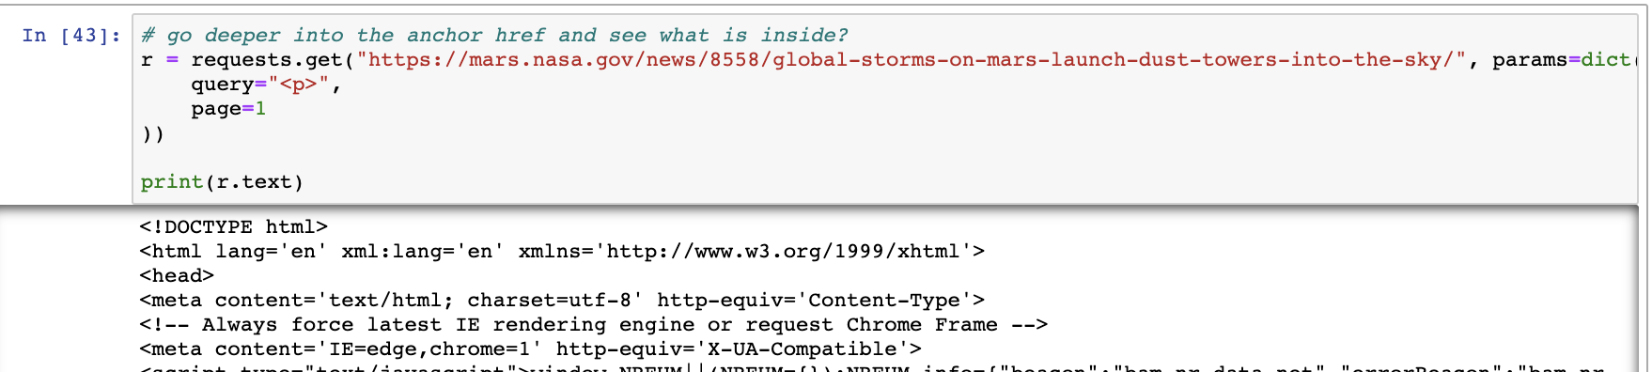

I scrape various <Titles>, Divisions, <Spans>, <Li>:

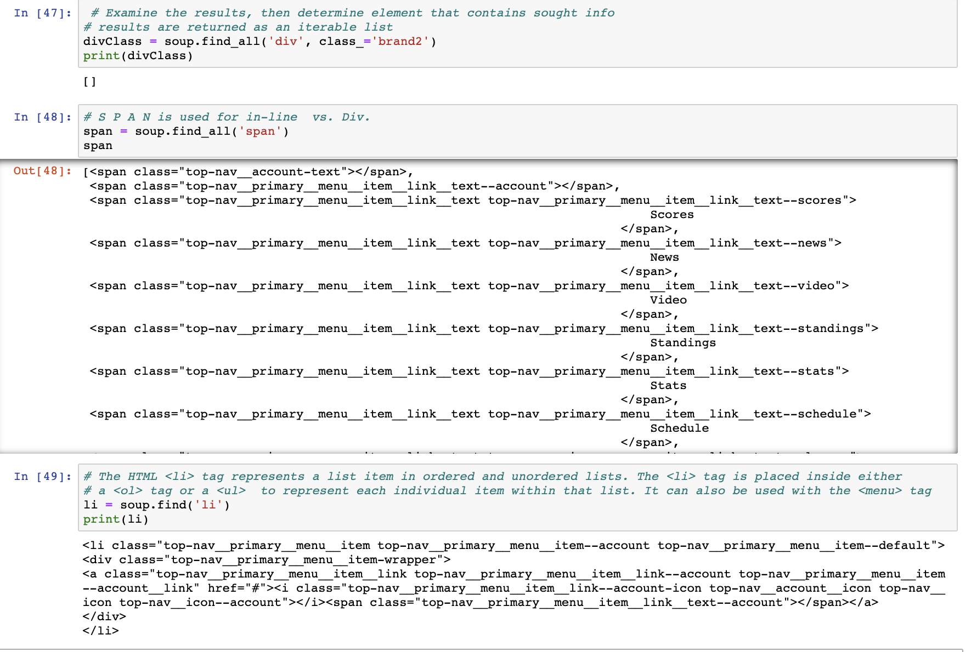

I was able to loop through a list of items, and post the dictionary of items:

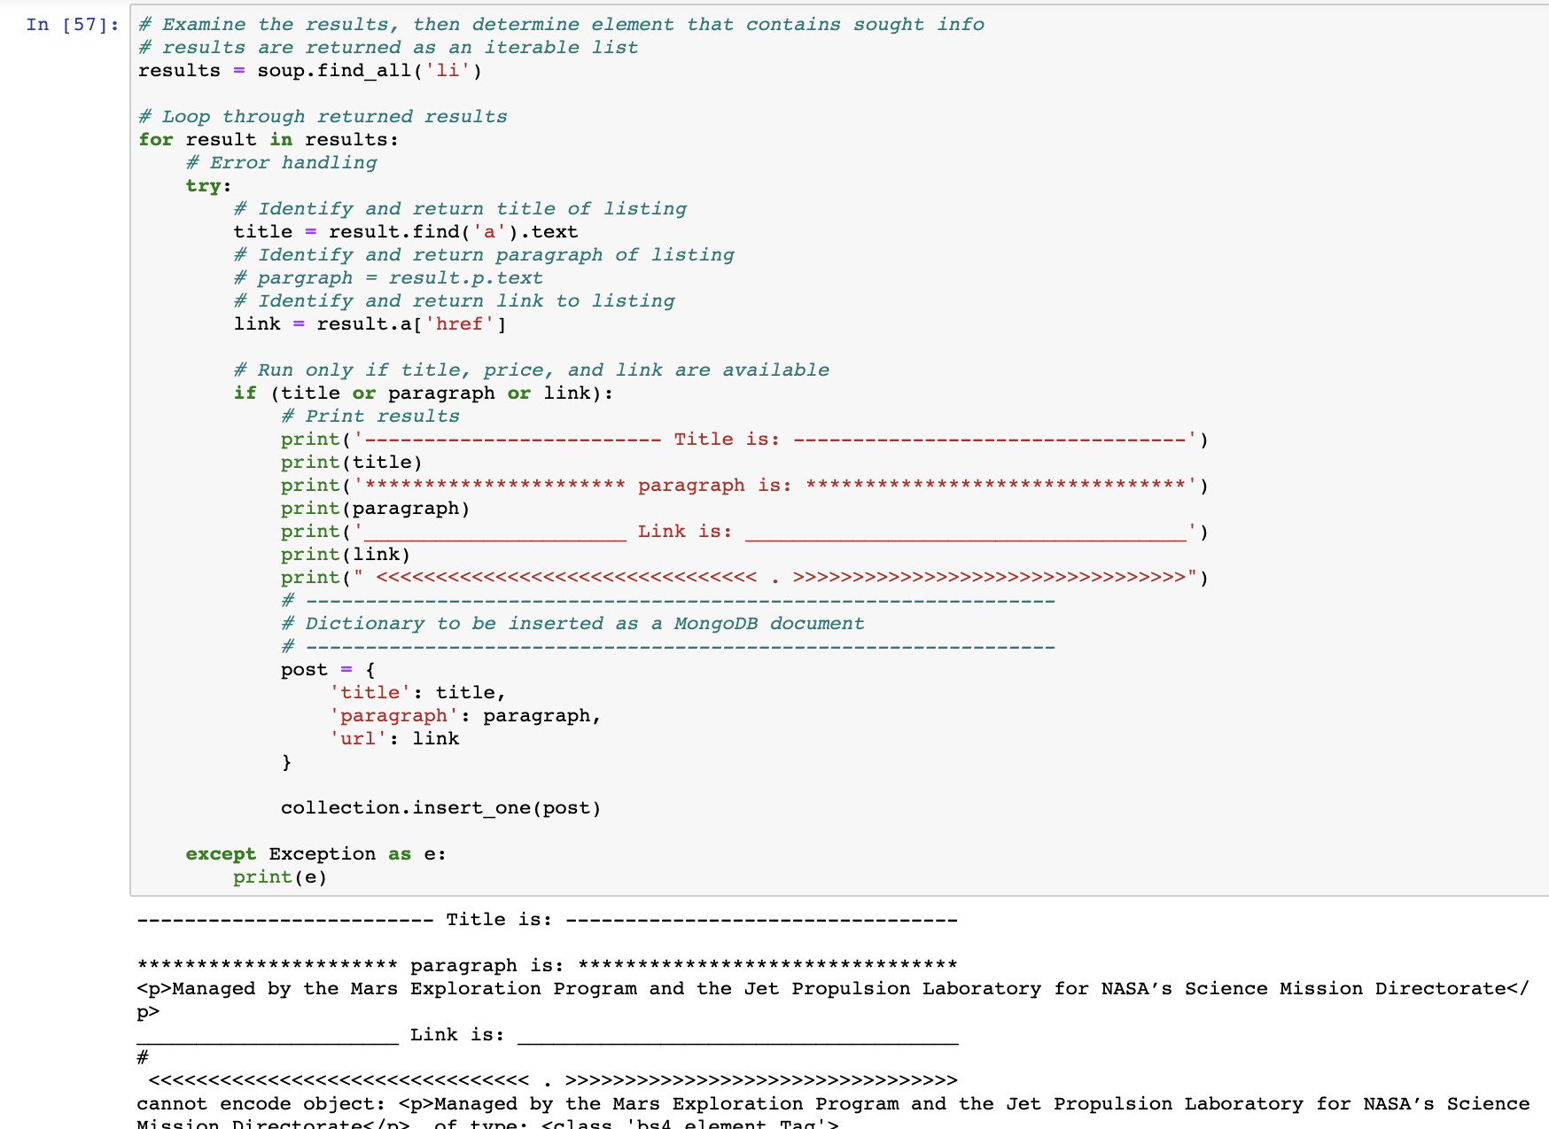

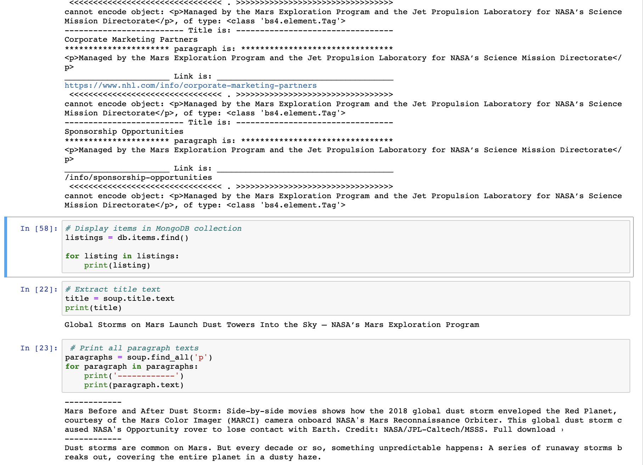

Via Chromdrive:

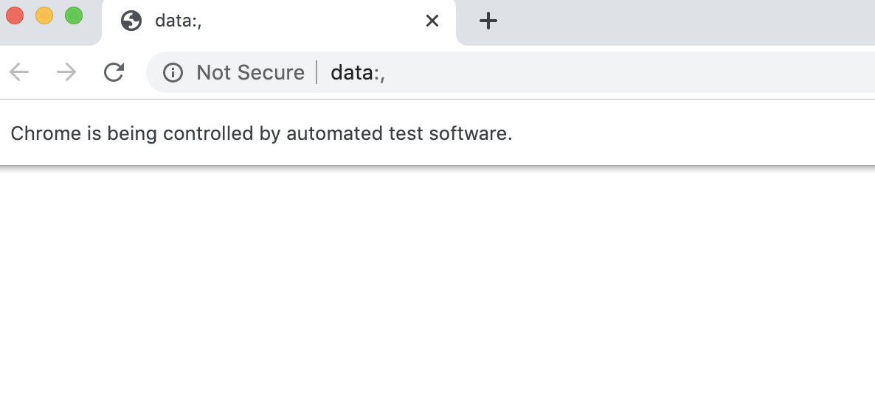

On the relation between “a” and “href” :

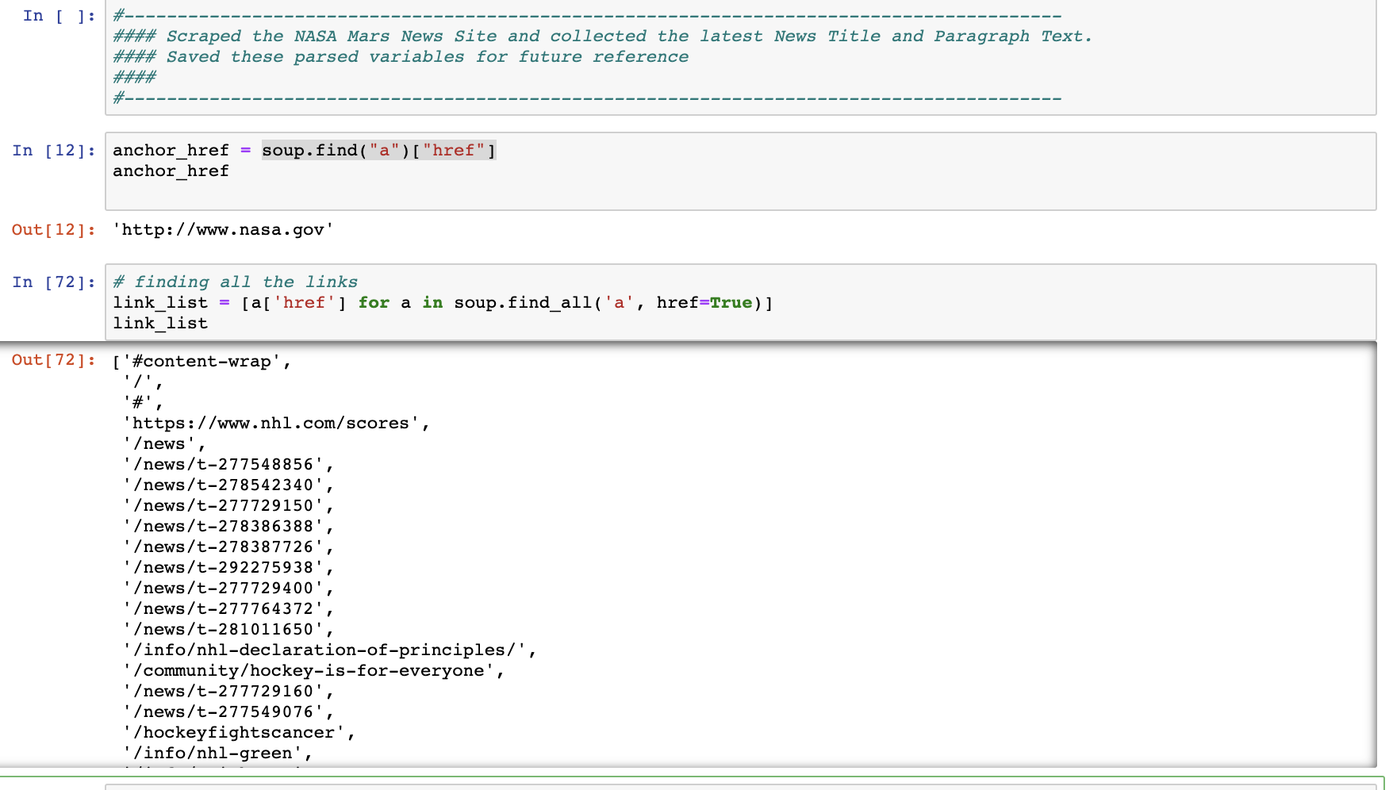

Insertions in MongoDb from a ollection of Nasa News Image links and its corresponding titles follows:

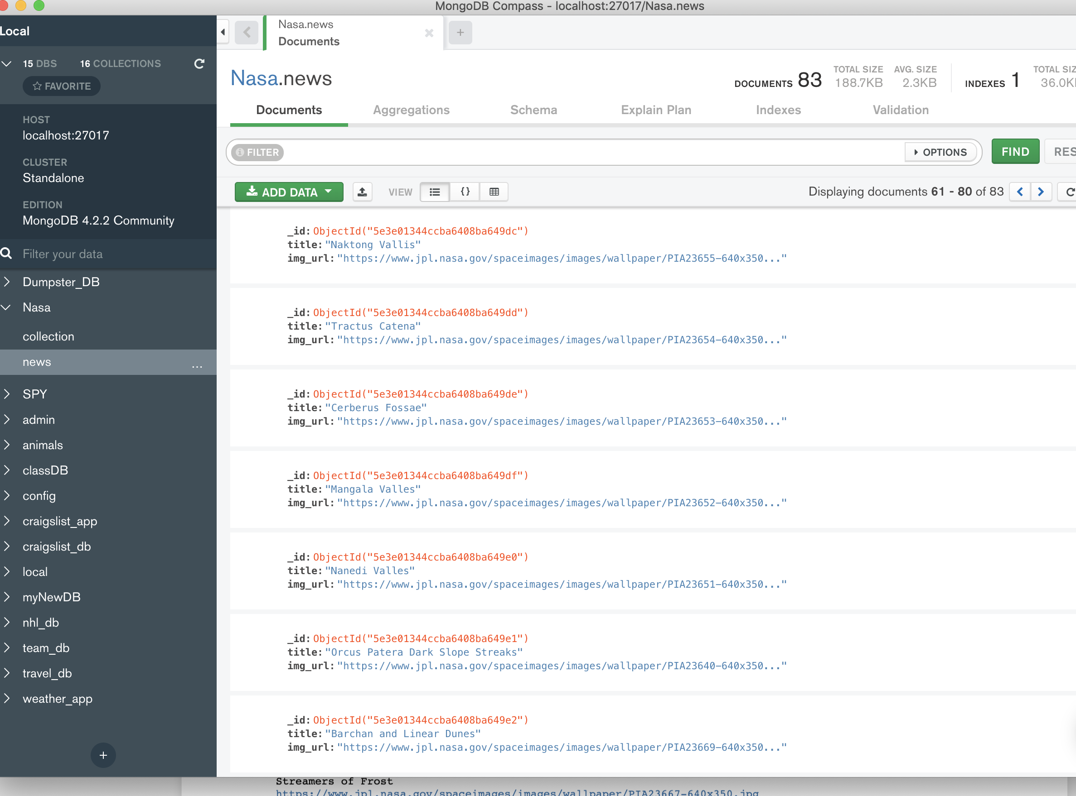

But we need an array of dictionaries to insert all the data! Which we did!!

As noted in: <https://www.youtube.com/watch?v=pWbMrx5rVBE>

Next I ran the APP.py

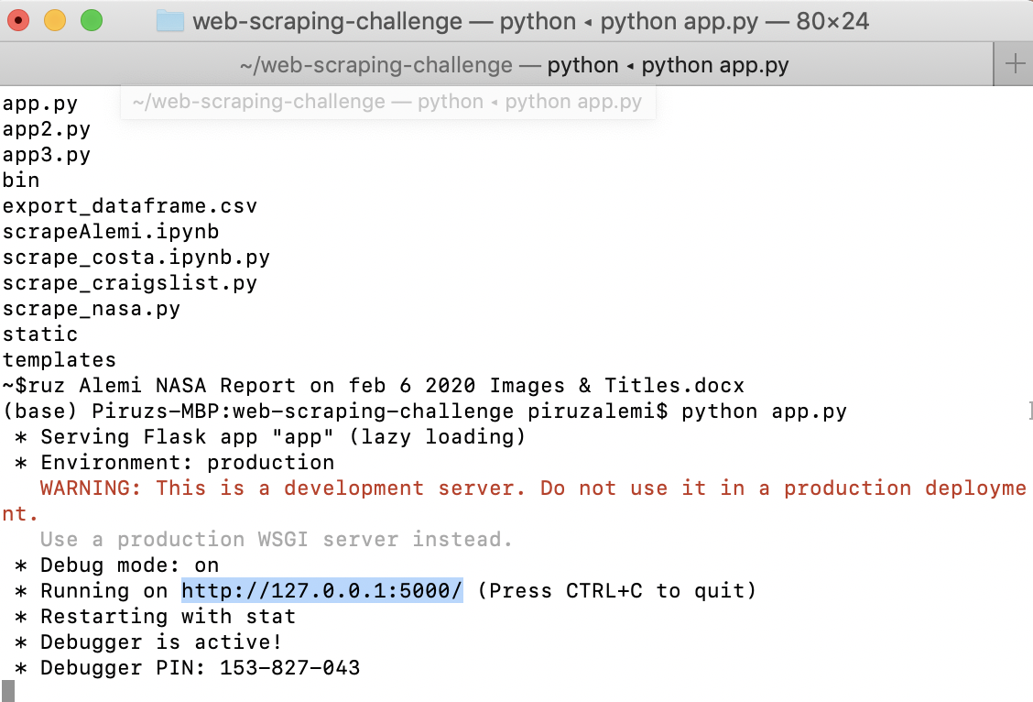

Running the above APP.PY with its corresponding Template & Index-HTML under Flask and its Routes / & /Scrape

We get:

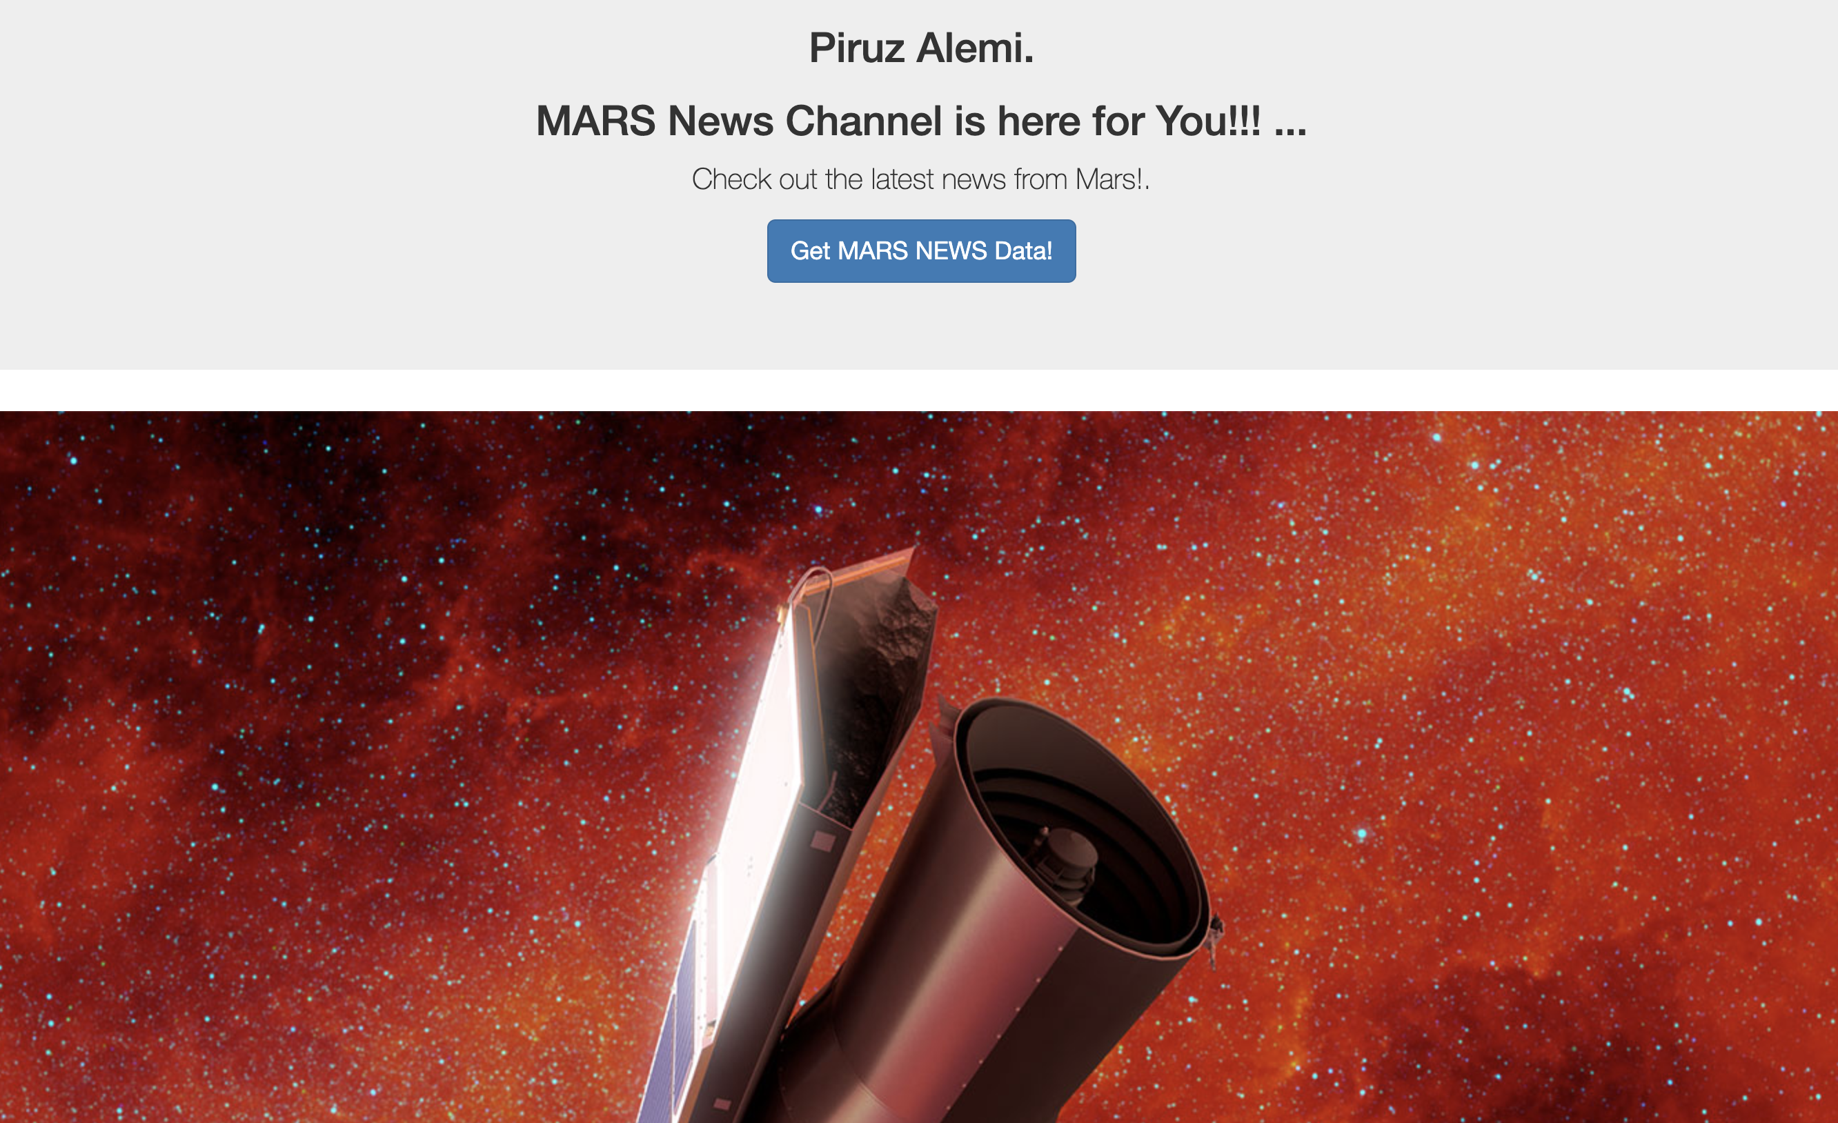

With its corresponding New Title:

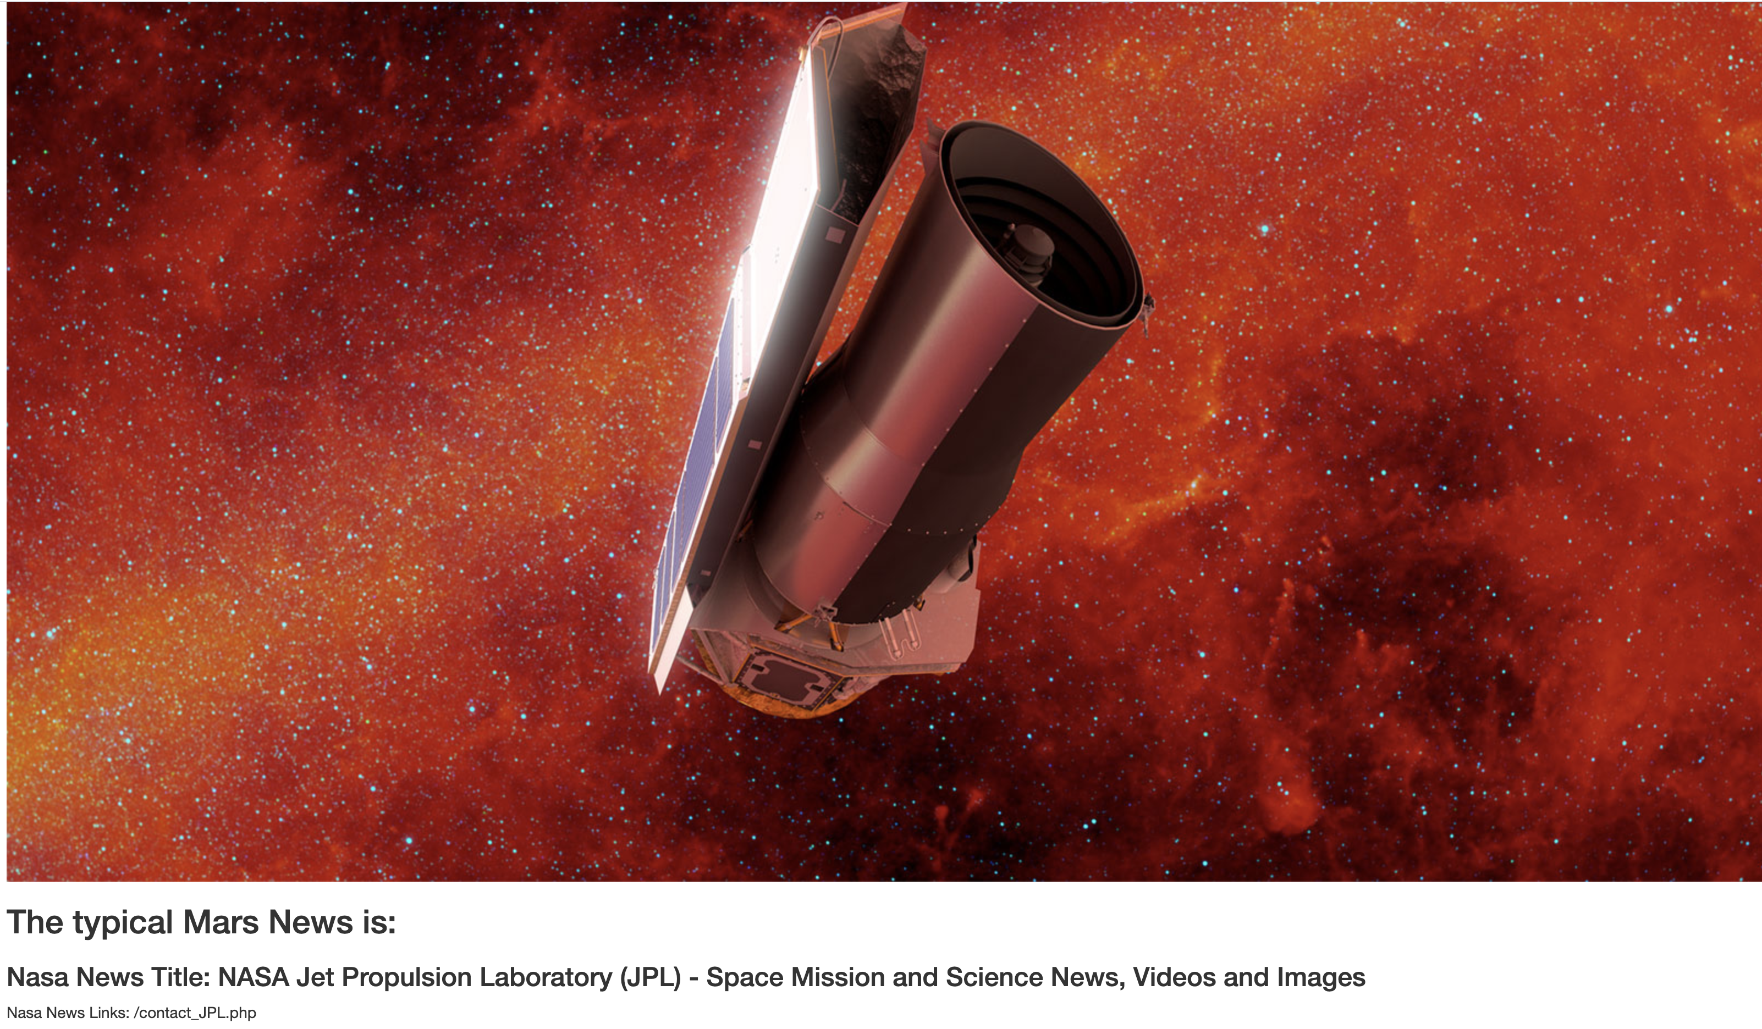

And a click() on Piruz Alemi Channel News, scrapes the following:

